COLEMAN UNIVERSITY Computer Information Systems Name: Michael Fetick
COM 280 Object Oriented Analysis and Design Student No. 84270
NOTE: The Syllabus, the Course Schedule and the Student Manual were provided only on a hard-copy media. After these class notes were typed, I have not transferred my written notes to text yet.
UML Fundamentals
Why model software? Planning is first and essential, like creating the blueprints for building a house.
- Achieve a high level of quality
- Enjoy a high level of:
  - Ease of development
  - Shorter development cycle
  - Provided better user documentation
- A good structure last a long time
- Even software modeling takes longer than development but development time is drastically reduced.
A picture is worth a thousand words. Object Modeling Technique (OMT) by Jim Rumbaugh.
The Unified Modeling Language (UML) is a standard pictorial language used to model software applications. UML was started in 1994 by Booch and Rumbaugh, and invented around 1997 by three superstars at Rational Software, Ivar Jacobson (use-case), Grady Booch, and Jim Rumbaugh (OMT, most prevalent contribution). They combined o-o analysis and design methodologies and created Rational Unified Process (RUP). RUP is a software application development process.
Three steps to create quality software: (ADI)
- Analysis – Project Planning. Recognize there is a problem to be solved. Investigate and understand the problem and the requirements for a solution. Ask the Domain Expert, things users deal with when they do the work.
- Design – The solution in detail
- Implementation – Build and installation of the system.
Software Lifecycle (three models):
- Waterfall Lifecycle Model (most common). Figure 1-2, page 4.
- Spiral Lifecycle Model (Iterative). Figure 1-3, page 5.
  - First phase – “Must have”
  - Second phase – “Nice to have”
  - Third phase – “Far-out”
- Increment – Iterative (most popular). Complete part of the system in a few iterations and give it to the user, then start on another part; then integrate later.
The Unified Modeling Process (UMP) (Newest) uses UML and has these four phases:
- Inception
  - What the system should do
  - Identify the business requirements
  - “Use Case” diagram, a simplified, layman’s look.
- Elaboration
  - Breakdown into sub-systems
  - Breakdown the “Domain Model” into
- Construction
  - Building of product, i.e. coding
- Transition
  - Delivery to the customer
  - Maintenance
  - Upgrade
Use Case Diagram
- Analysis
- Who uses what
  - Things in UML:
  - Structural – static
    - Class
    - Implementation
  - Behavioral
    - Use case
    - Activity
    - Sequence
    - Collaboration
    - State chart
Chapter 2, Use Case (on page 21 of student manual)
2.1 Definition:
- Starting point in the design of a new system: inception : analysis, identify business requirements in a system.
Why use “Use Case Diagrams”
- Illustrate functionality of a system
  - During normal processing
  - During exception processing
Use Case Diagram notational components:
- System – something that performs a function
- Actors
  - Users
  - Another system
- Use Case
  - Actions, verb + noun (oval shapes)
- Relationship
  - Include (subtasks). Dashed lines with open arrows pointing out to the subtasks.
Four types of relationships:
- Dependency
- Association
- Generalization.
- Realization
  - Generalization. We show inheritance (parent-child relationships). It shares the structure and behavior. It has an open-triangle, arrowhead that points to the parent. You must ask, “Is this a type-of” something? An example: Exception (parent), File not found (child).

  - Include and Extend (If) Relationships

Notation
- Activity (verb + noun)
- States i.e. Hungry, Full, Sleepy
- Transitions, move:
  - State >>> State
  - Activity >>> State
  - State >>> Activity
  - Activity >>> Activity
- Conditions (read on page 72)
  - Guard
  - Decision Points
Analysis based on the functional requirements:
- Identify actors
- Identify the primary business processes (use cases)
- Identify the supporting business processes (use cases)
- Identify the generalization relationships
- Identify the include relationships
- Identify the extend relationships
- Identify the relationships between actors and use cases
Exercises – Use Case Diagram
COLEMAN UNIVERSITY Computer Information Systems Name: Michael Fetick
COM 280 Object Oriented Analysis and Design Student No. 84270
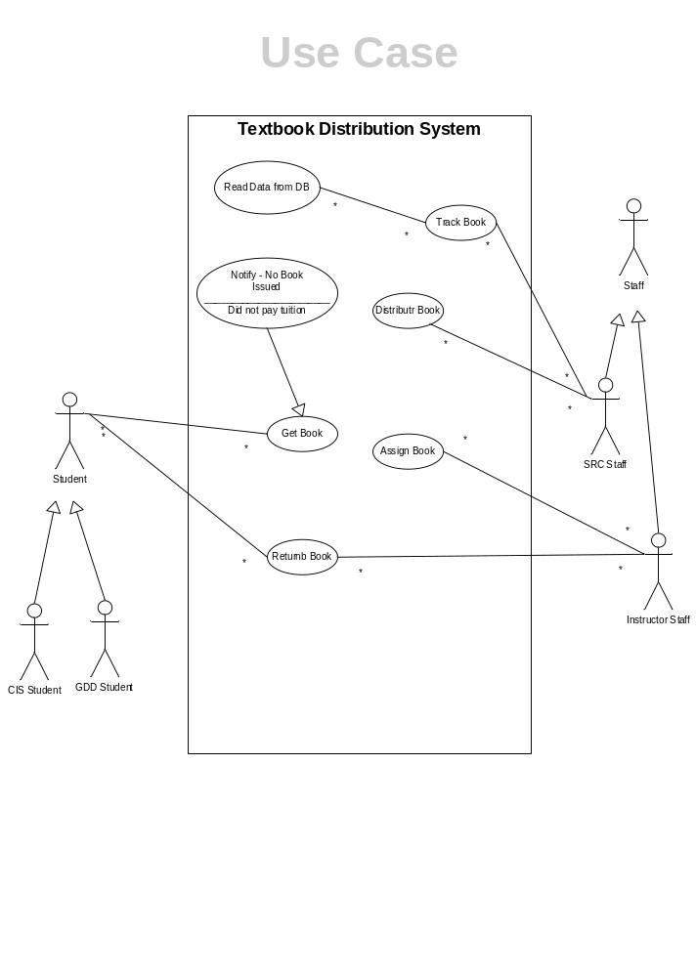
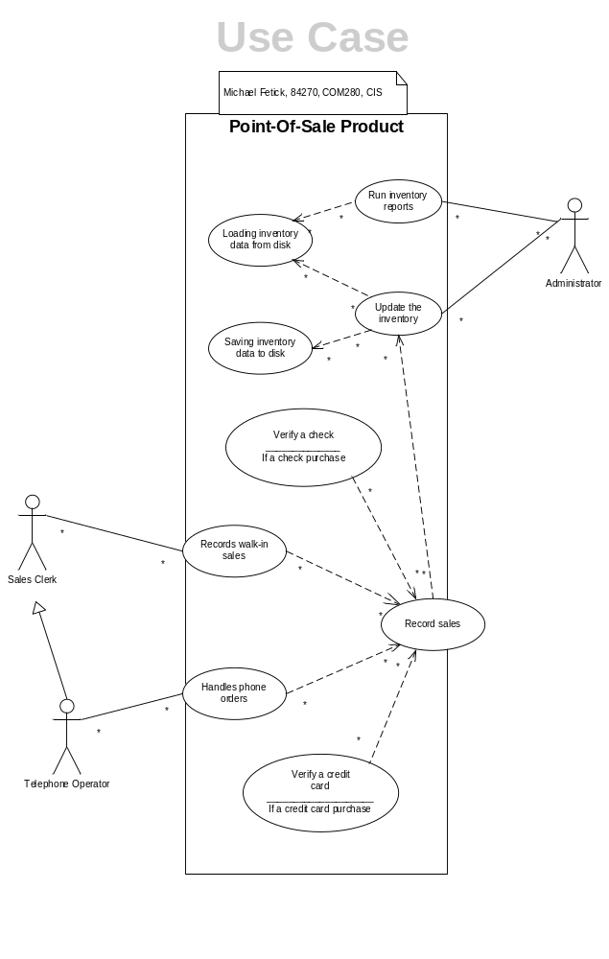
Project 1 – Use Case Diagram
Project Requirement

- Use Microsoft Word 2007 to list:
- Actors
- Primary use cases
- Supporting use cases
- generalization relationships
- include relationships
- extend relationships
- relationships between actors and use cases

- Use Microsoft Visio 2007 to draw a Use Case diagram to illustrate the above.
- Email instructor a Word document and a Visio drawing (ckoon@coleman.edu)
- Name of files: COM280 Project 1 Firstname Lastname

Project Due Date
Tuesday, June 4, 2013 11:30 p.m. PDT.
Details

Analysis of the “Automated University Library Circulation System”
Based on the functional requirements:
- Identify actors
  - potential borrower
  - valid borrower (students, faculty or staff, and guests)
  - library manager
- Identify the primary business processes (use cases)
  - searching
  - borrowing
  - book-maintenance activities
- Identify the supporting business processes (use cases)
  - searching by potential borrower
    - search by
      - title,
      - author,
      - keywords,
      - ISBN
    - search performed
      - on terminals in the library
      - via the Web
  - borrowing by borrower
    - checking books out to borrower
      - logically checking out the book
      - physically checking out the book
    - returning books in from borrower
      - logically returning the book
      - physically returning the book
  - book-maintenance activities by library manager
    - if a book is overdue, every Monday, the library sends reminder emails to borrowers who have overdue books
      - if a book is overdue more than two weeks, the borrower is assessed a fine
      - depending on how long the book remains overdue, the borrower can be assessed additional fines every Monday
    - if a requested book has been checked back in, sends email to notify the valid borrower, requesting the book, that the book is available
    - books being purchased by the library
      - logically add the book
      - physically add the book
    - books being returned in a damaged state
      - last borrower will be assessed a fine
        - however, if the book can be repaired, depending on the cost of the repair, the borrower might not be assessed a fine
      - logically remove the book
      - physically remove the book
- Identify the generalization relationships
  - borrower
    - potential borrower
    - valid borrower (students, faculty or staff, and guests)
  - search by
    - title search
    - author search
    - keywords search
    - ISBN search
  - search performed
    - search on terminals in the library
    - search via the Web
- Identify the include relationships
  - checking books out to borrower
    - logically checking out the book
    - physically checking out the book
  - returning books in from borrower
    - logically returning the book
    - physically returning the book
- Identify the extend relationships
  - if a book is overdue, every Monday, the library sends reminder emails to borrowers who have overdue books
    - if a book is overdue more than two weeks, the borrower is assessed a fine
    - depending on how long the book remains overdue, the borrower can be assessed additional fines every Monday
  - if the book of interest is currently checked out,
    - the system must update the library's collection database to reflect the book's new status
  - if a requested book has been checked back in, sends email to notify the valid borrower, requesting the book, that the book is available
  - the borrower's request should be honored
    - if the borrower is a student,
      - having the system check with the registrar's student database validates ID card
    - if the borrower is a faculty or staff member,
      - having the system check with the personnel office's employee database validates the ID card
    - if the borrower is a guest,
      - the ID card is checked against the library's own borrower database
    - if the ID card is valid,
      - the system must also check to determine whether the borrower has any overdue books
      - the system must also check to determine whether the borrower has any unpaid fines
  - the system must reject the borrower's request to check out a book
    - if the ID card is invalid,
    - the borrower has overdue books,
    - or the borrower has unpaid fines,
- Identify the relationships between actors and use cases
  - potential borrower can search
  - valid borrower can borrow (check-out) books
  - valid borrower can turn-in books
  - library manager checks-out borrowed books
  - library manager receives returned books
  - library manager sends reminder emails about overdue books and fines
  - library manager sends emails notifying borrowers of returned book requested
  - library manager assesses condition and repair of books
  - library manager assesses fines to borrower
  - library manager can add a book
  - library manager can remove a book

System Description
The functional requirements for an automated university library circulation system include the need to support searching, borrowing, and book-maintenance activities. The system should support searching by title, author, keywords, and ISBN. Searching the library’s collection database should be available on terminals in the library and available to potential borrowers via the Web. If the book of interest is currently checked out, a valid borrower should be allowed to request the book to be returned. Once the book has been checked back in, the borrower requesting the book should be notified of the book's availability.
The borrowing activities are built around checking books out and returning books by borrowers. There are three types of borrowers: students, faculty or staff, and guests. Regardless of the type of borrower, the borrower must have a valid ID card. If the borrower is a student, having the system check with the registrar's student database validates ID card. If the borrower is a faculty or staff member, having the system check with the personnel office's employee database validates the ID card. If the borrower is a guest, the ID card is checked against the library's own borrower database. If the ID card is valid, the system must also check to determine whether the borrower has any overdue books or unpaid fines. If the ID card is invalid, the borrower has overdue books, or the borrower has unpaid fines, the system must reject the borrower's request to check out a book, otherwise the borrower's request should be honored. If a book is checked out, the system must update the library's collection database to reflect the book's new status.
The book-maintenance activities deal with adding and removing books from the library's book collection. This requires a library manager to both logically and physically add and remove the book. Books being purchased by the library or books being returned in a damaged state typically cause these activities. If a book is determined to be damaged when it is returned and it needs to be removed from the collection, the last borrower will be assessed a fine. However, if the book can be repaired, depending on the cost of the repair, the borrower might not be assessed a fine. Every Monday, the library sends reminder emails to borrowers who have overdue books. If a book is overdue more than two weeks, the borrower is assessed a fine. Depending on how long the book remains overdue, the borrower can be assessed additional fines every Monday.
To begin with, we need to identify the major use cases and create a use-case diagram that represents the high-level business processes in the business situation just described. Based on the steps to identify the major use cases, we need to review the requirements definition and identify the boundaries (scope) of the problem. Based on the description of the problem, it is obvious that the system to be created is limited to managing the library's book collection. The next thing we need to do is to identify the primary actors and business processes that need to be supported by the system.
Based on the functional requirements described above:
- Identify actors
- Identify the primary business processes (use cases)
- Identify the supporting business processes (use cases)
- Identify the generalization relationships
- Identify the include relationships
- Identify the extend relationships
- Identify the relationships between actors and use cases

COLEMAN UNIVERSITY Computer Information Systems Name: Michael Fetick
COM280 Project 1 (5 points) Student No. 84270
